Instructions for requesting an NOI

A person from the company who is listed on your AZ Corporation Commission file must setup a MyDEQ account to request an NOI. If you don’t have an account, use the following link to set it up: https://azdeq.gov/mydeq Click on Request Account and Follow the registration steps. Here’s a video on that process.

Best practices to follow when applying for the NOI include:

- You will want to pick the General construction permit with (NOI/NDC)
- When asked if water will run off the site into US Tributary waters, select yes. If you select No or unknown, it will generate an NDC certificate which must be canceled before you can reapply for the NOI.
- When asked where the water will run off the site, you will select an overlay map. Place your cursor on the lowest point of the job site where water run off could occur. It will then produce an overlay map showing the latitude and longitude for the NOI.
- It will ask what MS4 the water will run off to and you will pick the city the jobsite is located in.
- When asked what the nearest body of water to the site is, type in the name. If you don’t know, you can use the drop-down menu and pick unknown or unnamed.
- You will not need to have the SWPPP reviewed.
- You will need to provide a contact name for the super or person in charge of the site on a daily basis. They will request name, contact number and email address.

Please Call 844-827-4768 if you have any questions setting up the account and if you have questions regarding the NOI request process.
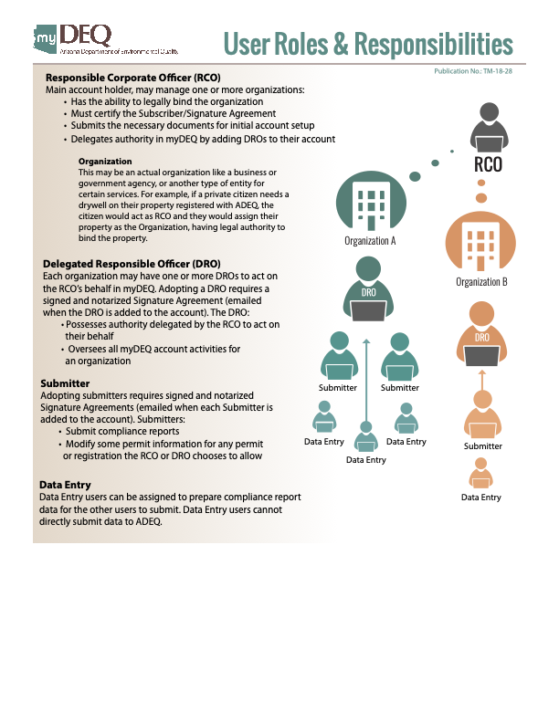
Jayson Roti
Desert Services
jayson@desertservices.net
602-722-0218 Cell
480-513-8986 Office

